Resistance of a Fluorescent Bulb
Plasma Tube with Power Supply Version

Part of a Series of Activities in Plasma/Fusion Physics
to Accompany the chart

Fusion: Physics of a Fundamental Energy Source

Robert Reiland, Shady Side Academy, Pittsburgh, PA
Chair, Plasma Activities Development Committee of the
Contemporary Physics Education Project (CPEP)

Editorial assistance: G. Samuel Lightner, Westminster College, New Wilmington, PA and Vice-President of Plasma/Fusion Division of CPEP

Advice and assistance: T. P. Zaleskiewicz, University of Pittsburgh at Greensburg (emeritus), Greensburg, PA and President of CPEP; Cheryl Harper, Greensburg-Salem High School, Greensburg, PA and Chair of the Board of CPEP; Todd Brown, University of Pittsburgh at Greensburg, Greensburg, PA, and associate member of CPEP

Prepared with support from the Department of Energy, Office of Fusion Energy Sciences, Contract #DE-AC02-76CH03073.

©2015 Contemporary Physics Education Project (CPEP)

Preface

This activity is intended for use in high school and introductory college courses to supplement the topics on the Teaching Chart, Fusion: Physics of a Fundamental Energy Source, produced by the Contemporary Physics Education Project (CPEP). CPEP is a non-profit organization of teachers, educators, and physicists which develops materials related to the current understanding of the nature of matter and energy, incorporating the major findings of the past three decades. CPEP also sponsors many workshops for teachers. See the homepage www.CPEPweb.org for more information on CPEP, its projects and the teaching materials available.

This activity packet consists of the student activity followed by some general background information and then notes for the teacher. The Teacher’s Notes include background information, equipment information, expected results, and answers to the questions that are asked in the student activity. An appendix to the Teacher’s Notes shows the alignment of the activity with the National Science Standards and with the AAAS Benchmarks. The student activity and general background are self-contained so that they can be copied and distributed to students. Page and figure numbers in the Teacher’s Notes are labeled with a T prefix, while there are no prefixes in the student activity. The page number and figures in the separate background section are labeled with a B prefix.

Developed in conjunction with the Princeton Plasma Physics Laboratory and funded through the Office of Fusion Energy Sciences, U.S. Department of Energy, this activity has been field tested at workshops with high school and college teachers.

We would like feedback on this activity. Please send any comments to:

Robert Reiland
Shady Side Academy
423 Fox Chapel Road
Pittsburgh, PA 15238

e-mail: robreiland1@comcast.net
voice: 412-968-3049

Resistance of a Fluorescent Bulb
Plasma Tube with Power Supply Version

Part of a Series of Activities in Plasma/Fusion Physics
to Accompany the chart

Fusion: Physics of a Fundamental Energy Source

If you've studied simple electric circuits, you may have learned about a characteristic of many circuit elements called electrical “resistance.” In general we can say that when an electrical current is produced through an object as a result of a voltage (potential difference) across the object, the ratio of voltage to current is the resistance of the object. In many cases we want this ratio to be nearly constant for a wide range of voltages. However, this will not be true for most things that get noticeably hot when carrying moderate currents, for example an incandescent bulb. Fluorescent bulbs don't tend to get very hot, but does that mean that they necessarily have constant resistances? This is the question to be answered by this activity.

Procedures:

1. Turn on the power supply and ignite the bulb using the push button on the side of the power supply. Ideally you will have two multimeters or voltmeters. In this case each should be set on dc volts (maximum setting of 10, 20 or 30 volts). Otherwise you will use one meter to make both sets of measurements needed, but the settings on the meter (dc volts and maximum number of volts) should be the same for both sets.
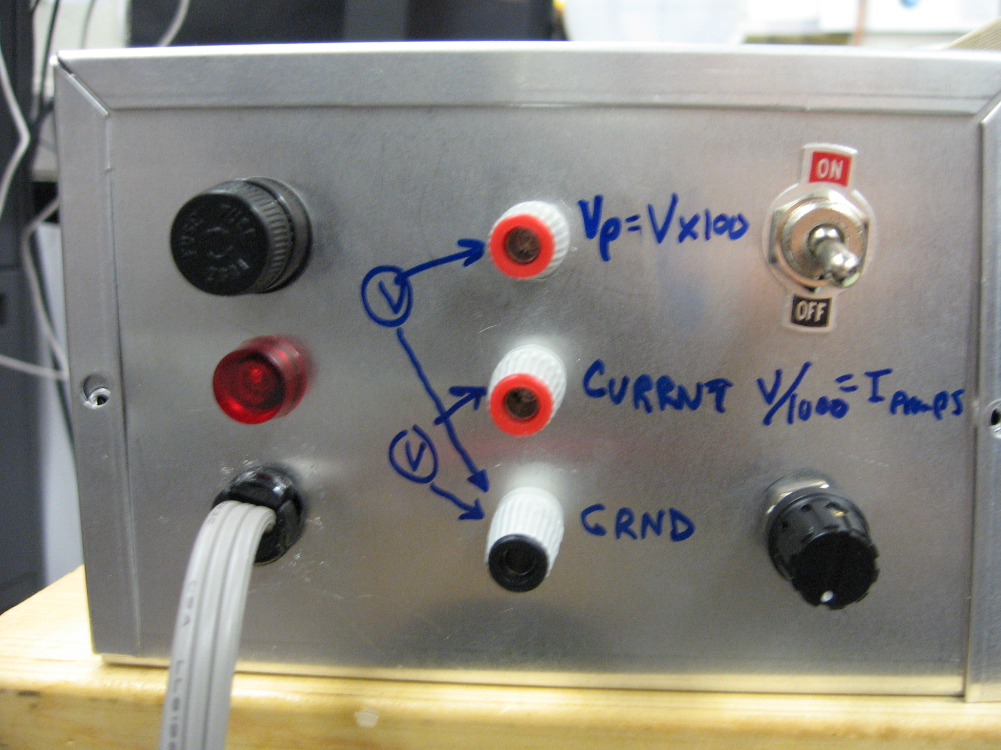Prepare to measure voltage and current using the test points marked Voltage (for plasma voltage) and Current (for current through the tube). See figure 1. Record voltage with the common probe of the multimeter in the terminal marked Ground and the wire from the voltage connection of the multimeter in the Voltage test point. Since this is an indirect measurement, multiply the reading on the multimeter by 100 to get the actual plasma voltage. Then record current with the common probe again in Ground and the other probe wire in the Current test point. Again because this is an indirect measurement, use the number of volts indicated on the multimeter as the current in milliamperes. If you have two meters, both should have their common probes connected to the terminal marked Ground. Connect the other probe of one meter to the Voltage test point for voltage measurements, and connect the other probe of the second meter to the Current test point.
Figure 1

Use the black potentiometer knob on the lower right to change the applied voltage in about 50 volt increments (seen as 0.5 volt increments on the meter), and repeat the set of voltage and current measurements several times. If two meters are connected for the measurements, read the numbers at the same time. Otherwise, wait a few seconds for either the current or the voltage reading to stabilize, read off the number on the meter, and quickly move the meter probe from the Voltage test point to the Current test point or vice versa to get the other reading.

2. Graph voltage versus current. If you get a straight line whose intercept is very close to the origin, your bulb has a constant resistance, which is equal to the slope of the line. In any other case your bulb has resistance that isn’t the same at all voltages. You can see this by noting that resistance can be calculated with each set of measurements by dividing the voltage by the current. Carry out this calculation for at least three data sets. One should be near the low voltage end of the data, one near the high voltage end and one near the middle.

Questions:

- Does the electrical resistance of a fluorescent bulb increase with increasing voltage, decrease or stay nearly the same?

- Increasing voltage across a fluorescent bulb should increase the rate at which electrical charge carriers, electrons and positive ions, move in producing the measured electrical current. Considering the way and the amount in which the electrical current changes as the voltage is increased, does it seem likely that an increase in the rate of motion of the electrical charge carriers alone can account for the observed changes in electrical current? If not, what other factor or factors could be involved?

- Assuming that any increase in current is due solely to an increase in the number of charges carriers, calculate the ratios of the number of charge carriers at each voltage you used to the number of charge carriers at the lowest voltage you used.

Check the information in the article by Nicholas Guilbert* and talk to your teacher for clues as to why the resistance should follow the pattern you found.

General background on conduction (and resistance):

In general we can say that when an electrical current is produced through an object as a result of a voltage (potential difference) across the object, the ratio of voltage to current is the resistance of the object. In the case of commercial “resistors”, this resistance will be nearly constant for a wide range of voltages, that is, the graph will be of a nearly straight line with intercept very close to the origin. We then say it obeys Ohm's "Law". However, this will not be generally true. For example, it doesn’t work this way for most things that get noticeably hot when carrying moderate currents.

There are two variables that determine the electrical current in a conductor. These are the number of charge carriers per volume of conductor, such as electrons and ions, and the systematic motion, or "drift velocity" of the conducting charges. Increasing either or both of these will increase the current in a conductor.

It is important to distinguish between the random motion and the systematic motion of the charge carriers. Atoms and molecules in a gas tend to be moving rapidly, but in a confined gas they scatter off one another and off the walls of containers. On the average the individual particles making up the gas don’t get far between collisions. This is analogous to people at a party in a crowed room. People often try to move rapidly (for example to get to another person or to the food table), but as they move they constantly “bump” into other people and so get diverted from their path. This kind of motion doesn't produce a "current" of people in the room because on average for every person who moves toward one side of the room (for example, to the food), there is another person who moves to the other side (for example, away from the food). A "current" of people is only produced if people are moving into or out of the room. In particular, if the number of people in the room is somehow kept fairly constant, a "current" of people can only result if people are moving into the room through one door and out through a different door. For this to happen some of the motion of the people involved must be systematically from the entrance door to the exit door. Because of all of the "bumping" this systematic motion will be slower than the speed of a person moving from one "bump" to the next "bump."

This is similar to what happens when an electrical current is produced in a wire. In a typical conductor, such as a bit of metal wire, electrical currents are carried by electrons that are shared by all of the metal atoms. These are the conducting electrons. Each metal atom contributes its valence electrons (electrons in the highest energy level of the atom) to produce this "gas" of shared conducting electrons. The number of conducting electrons per volume in the wire stays about the same while electrons are moving into the wire on one end and out of the wire on the other end. The electrical current is then determined by the average systematic motion of the electrons (drift velocity) times the nearly constant number of electrons per volume free to move times the area of the wire that they move through. This is the same as the rate of electrons entering the wire at one end or leaving at the other end.

Since the number of electrons available to carry a current is fixed for a wide range of temperatures, the current through the metal can only be increased by increasing the drift velocity of the conducting electrons. It might then be expected that as the voltage across a metal wire is increased, the greater push on the conducting electrons produced by the increase in voltage will increase the speed of electrons in a simple way. The simplest result would be that the current increases directly with the applied voltage.

There are several reasons that things don't always work this way. The first is that most of the speed of the electrons is in random directions and at rates that are typically on the order of one million meters per second. In fact, the conducting electrons of any given metal have a characteristic average speed that is totally independent of the temperature of the metal for a wide range of temperatures! For some, this characteristic speed is less than one million meters per second. For others it is over one million meters per second, but the variation from the highest to the lowest average speed is less than a factor of two. That is, for all metals the characteristic average speed of electrons is on the order of one million meters per second.

If this doesn't seem to make sense at first thought, it is because the motions of electrons making up the electron "gas" in solid metals can only be understood on the basis of quantum mechanics. The electron gas is very much a non-classical gas, or as hinted at in the bottom right corner of the graph "Plasmas - The 4th State of Matter" in the Fusion: Physics of a Fundamental Energy Source chart*, it is a non-classical plasma.

While the random motion of electrons in metals is around one million meters per second, the "systematic" motion that is imposed on this random motion as a result of an applied voltage from one end of the piece of metal to the other is typically less than a millimeter per second!
Energy that might be expected to be added to conducting electrons by applied voltages is mostly transferred to the metal as a whole as the electrons scatter off defects and impurities in the metal. In other words, when an electrical current is produced in metal, the metal gets warm or even hot, but the electrons don't move noticeably faster. Then the warmer metal tends to scatter electrons more and reduces the tendency toward increasing systematic motion of the electron gas.

The moving electrons then scatter off the atoms in all directions. Each time this happens to an electron, most of the systematic velocity it developed in contributing to the total current is lost. The higher the temperature, the greater the motion of the atoms, and this results in the electrons losing their systematic motion at higher rates. The outcome is that for most simple conductors, the rate at which current increases with voltage continuously drops. That is, most metals have higher resistance at higher temperatures because the conducting electrons interact more strongly with the atoms as the atoms move more rapidly with increasing temperature.

For such materials, including all metals under common conditions, the graph of applied voltage versus electrical current will have a continuously increasing slope indicating that the resistance increases with voltage.

In ordinary incandescent light bulbs the filament is made of tungsten, which like other metals becomes more resistive at higher temperatures. Since an operating incandescent light bulb filament will typically be at a temperature of 2000 to 2600 degrees Celsius, the resistance of the filament will change considerably from the near room temperature measurements made at the lowest voltages to those made at normal operating voltages.

As we see from this discussion most materials don't have constant resistances over a wide range of temperatures. Except for a few specially prepared materials, the expectation that resistances tend to be constant is simply due to the fact that, unlike the incandescent bulb, the range of temperatures attained in most parts of electrical circuits is not large. Often voltages will vary a lot more than temperatures will, and in this case resistance tends to be nearly constant in most circuit parts.

Semiconductors are an example of how the changing number of charge carriers affects the resistance. This is because a rise in temperature frees more charge carriers, whereas in the conductor the number of charge carriers remained essentially constant. This means a semiconductor actually has lower resistance at higher temperatures.

So far electrical currents have been described as resulting from the systematic motions of electrons in solids. A very different situation results when the current is carried by electrons and ions in a partially ionized gas, also known as "classical plasma". Such a system is what carries the currents inside a fluorescent bulb.

When the voltage is increased across a fluorescent bulb, the effects start out the same as those produced by a voltage increase across a metal wire. Electrons and ions that are mobile in the plasma gain energy and then quickly lose much of it by scattering off other ions and electrons and also by scattering off neutral atoms. But there are two additional processes occurring in the plasma that do not normally occur in a metal wire. One is that electrons and ions that lose enough energy in these collisions may recombine to form neutral atoms. The other is that electrons and ions that gain enough energy between collisions from the applied voltage may ionize neutral atoms to form new electrons and ions. At a constant voltage these opposite processes achieve a dynamic equilibrium in which they occur at the same rate and keep the total number of current carrying electrons and ions fairly constant.

* “Shedding Some Light on Fluorescent Bulbs” by Nicholas R. Guilbert, Phys. Teach. 34, 20-22 (1996), January, 1996
* CPEP chart available from Wards Scientific or from Amazon.

